CAN (CONTROLLER AREA NETWORK) ELEVATOR TEST DOCUMENT
engineering project (EECE73125)
  - Dinkar Sharma, Mike Akl, Anas Yassin
2017
Contents
Purpose 2
Audience 2
System Overview 2
Phase 1 3
1.0 Elevator Call Station Nodes 3
1.1 Elevator Call Station Buttons 3
1.2 Elevator Call Station Lights 3
1.3 Elevator Call Station Display 4
1.4 Elevator Car Door States 4
1.5 Elevator Car Door Lights 4
1.6 Elevator Car Floor Selection Buttons 5
1.7 Elevator Car Floor Selection Lights 5
1.8 Elevator Car Display 5
Phase 2 6
Phase 3 6

Purpose
The purpose of this document is to outline the test strategy and overall test approach for the CAN (Controller Area Network) Elevator project. This document includes test methodologies, estimated schedule, and resources requirement. The testing is separated into three separate phases with the final phase being integration of the components. The test cases are derived from the technical requirements of the system as well as the common CAN bus protocol used to communicate with the system.

Audience
The primary audience for this document are the project team members whom will be the primary testers. This document is also written for the faculty member of ESE who will evaluate this project.

System Overview
This section provides an overview of the system architecture in terms of the components that are tested during the unit test phase. Their dependencies are defined in this section.
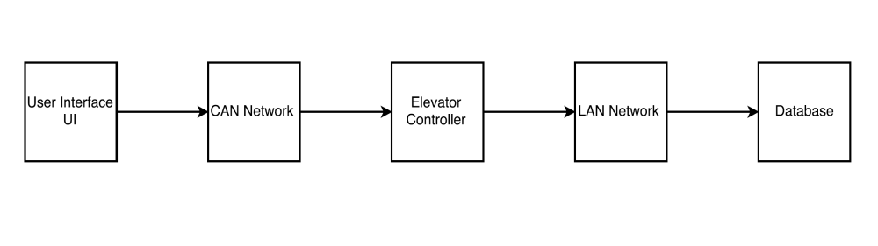
Figure 1 CAN Controller Elevator Architecture

Phase 1

Elevator Call Station Nodes
Floor | Node ID Assigned | Node ID Tested
1 | 0x201
2 | 0x202
3 | 0x203

1.1 Elevator Call Station Buttons
Floor | Expected CAN Frame for Button Press UP | Expected CAN Frame for Button Press DOWN | Actual CAN Frame for Button Press UP | Actual CAN Frame for Button Press DOWN
1
2
3

1.2 Elevator Call Station Lights
For this test, a green LED will indicate a request for elevator DOWN at each call station. A yellow LED will indicate a request for elevator UP at each call station.
Floor | Expected Light to Be Lit for Button Press UP | Expected Light to Be Lit for Button Press DOWN | Actual Light Lit for Button Press UP | Actual Light Lit for Button Press DOWN
1
2
3

1.3 Elevator Call Station Display
Floor  Selection | Expected Distance (cm) At Each Floor | Actual Distance (cm) Measured At Each Floor
1
2
3

1.4 Elevator Car Door States
Floor | Expected CAN Frame for Button Press UP | Expected CAN Frame for Button Press DOWN | Actual CAN Frame for Button Press UP | Actual CAN Frame for Button Press DOWN
1
2
3

1.5 Elevator Car Door Lights
For this test, the axman LEDs will be used to indicate door open and closed
Floor | Lit LEDs | Expected Light to Be Lit for Door CLOSE | Actual Light Lit for Door OPEN
1 | LED1 ON | ----------- | Door is open
2 | LED2 ON | Door is closed | -----------

Elevator Car Floor Selection Buttons
Floor  Selection | Expected CAN Frame | Actual CAN Frame
1 | 1 | 1
2 | 2 | 2
3 | 4 | 4

1.7 Elevator Car Floor Selection Lights
For this test, three green LEDs will be used to assign to a single floor. The LEDs will be aligned vertically and the most bottom LED will indicate floor selection one, middle will indicate floor 2, and most top will indicate floor 3. During a floor selection the respective LED will be ON and the rest OFF.
Floor | Expected Light to Be Lit per Floor Selection | Actual Light Lit per Floor Selection
1 | Bottom LED ON | RED
2 | Middle LED ON | RED
3 | Top LED ON | RED

1.8 Elevator Car Display
Floor | Expected Floor Number to Be Displayed | Actual Floor Number Displayed
1 | 1 | 1
2 | 2 | 2
3 | 3 | 3

Phase 2
TBD

Phase 3
TBD

